

Project Submitted to the

**LOVELY PROFESSIONAL UNIVERSITY**

PUNJAB

Submitted by **KOC-35**

**Koventhan M (12217318) Roll no:60**

**Ishan Jack Jojo (12218257) Roll no:01**

**Sinan (12222085) Roll no:57**

In the academic year

2022-2023

Under the guidance of

**Sir Nitesh Kumar**

Department of Computer Science Engineering (CSE326)

**ACKNOWLEDGEMENT**

The successful completion of any task would be incomplete without mentioning the name of the faculty who helped to make it possible. We take this opportunity to express my gratitude in few words and respect to all those who helped us in the completion of this project. It is our humble pleasure to acknowledge our deep senses of gratitude to our CSE326 (Internet Programming Laboratory) Faculty **Sir Nitesh Kumar** for his valuable support, constant help and guidance at each and every stage, without which this project would not have come forth. We would also like to thank our friends and our family for encouraging us during the course of this project. Last, but not the least, We would like to thank Department of Computer Science Engineering for giving us the opportunity to undertake this project.

**SOFTWARE & HARDWARE REQUIREMENTS**

**HARDWARE:**

1. Processor – Pentium(R) G2030@ 3.70 GHz
2. RAM: 4 GB
3. System Architecture: 32 or 64 bit Operating system
4. HDD: 500 GB

**SOFTWARE:**

1. Operating system: Linux- Ubuntu 16.04 to 17.10, or Windows 7 to 10
2. Notepad

**ABSTRACT**

The main objective of the HTML Project on Railway Reservation System is to manage the details of Booking, Holiday Packages, Meals, Service, Contact us . It manages all the information about Booking, Holiday Packages, Meals, Service, Contact us . .

**SOURCE CODE**

INDEX.HTML

<!DOCTYPE html>

<html>

<head>

<title>Railway Ticket Booking</title>

<link rel="stylesheet" href="index.css"/>

</head>

<body>

<div class="main">

<h1 class="head">Railway Ticket reservation system</h1>

<div class="navigation"> <!-- abhinandan-->

<ul>

<li><a href="index.html" id="onlink">HOME</a></li>

<li><a href="meal.html">MEALS</a></li>

<li><a href="holiday.html">HOLIDAY</a></li>

<li><a href="service.html">SERVICE</a></li>

<li><a href="contact.html">CONTACT US</a></li>

</ul>

</div>

<div class="booking">

<section>

<h2 class="head1">Book</h2>

<h2 class="head2">Your</h2>

<h2 class="head3">Tickets</h2>

<h2 class="head4">Here</h2>

<form><!-- abhinandan-->

<ul>

<b class="fsize"> From &emsp;<input type="text" placeholder="From [STN Code]"> </b> <br> <br>

<b class="fsize"> To &emsp;<input type="text" placeholder="To [STN Code]"> </b> <br> <br>

<b class="fsize"> Date&emsp;<input type="Date" placeholder="dd-mm-yy"> </b> <br> <br>

<label class="fsize"><strong> Class </strong> </label>

<select id="class" name="class">

<option value="select">SELECT</option>

<option value="1AC">1AC</option>

<option value="2AC">2AC</option>

<option value="3AC">3AC</option>

<option value="Sleeper">Sleeper</option>

<option value="Chair">Chair</option> <br>

</select>

</ul>

</form>

<button class="submit" type="button" onclick="trainB()">Find Trains </button>

<div class="form-popup" id="bookTrain">

<div class="popup">

<h1>Due to Covid19 all trains are currently cancelled</h1> <br>

<h2>#stayhome</h2>

<h2>#staysafe</h2>

<button type="button" class="hide" onclick="trainC()">Close</button>

</div> </div>

</section>

</div><!-- abhinandan-->

<img class="img" src="C:\Users\dell\Desktop\home.jpg" alt="train" width="500" height="350" align="center" />

<h1 class="holiday">HOLIDAYS</h1>

<img class="imgs" src="C:\Users\dell\Desktop\taj.jpg" alt="Taj Mahal"/>

<img class="imgs" src="C:\Users\dell\Desktop\temple.jpg" alt="Golden Temple"/>

<img class="imgs" src="C:\Users\dell\Desktop\tower.jpg" alt="Eiffel Tower"/>

</div>

<script src="main.js"></script>

</body>

</html>

Index.css

body{

margin: auto;

background-color:lightgrey;

font-family: arial;

}

.navigation{

margin:auto;

width: 860px;

padding: 0px 0px 0px 130px;

height: 50px;

margin-top: 20px;

}

.navigation ul{

padding: 0;

list-style: none;;

}

.navigation ul li{

float: left;

font-size: 20px;

font-weight: bold;

margin-right: 10px;

}

.navigation ul li a{

text-decoration: none;

color: darkblue;

background:lightpink;

border-top: 1px dotted black;

border-left:1px dotted black;

border-right: 1px dotted black;

border-bottom: 1px dotted black;

padding: 10px 20px 10px 20px;

border-top-right-radius:10px;

border-top-left-radius:10px;

border-bottom-right-radius:10px;

border-bottom-left-radius:10px;

display: block;

text-align: right;

}

.navigation ul li a:hover{

text-decoration: none;

color:darkred;

background: lightgreen;

}

.navigation ul li a#onlink{

background:grey;

color: orange;

border-bottom: 1px solid red;

}

.navigation ul li a#onlink:hover{

background:white;

color: orange;

}

.main{

margin: auto;

width: 860px;

padding: 10px;

border:1px solid red;

background: lightyellow;

min-height: 600px;

}

.booking {

margin:0px;

padding:0px 100px 0px 0px;

border:1px solid black;

width: 150px;

float: left;

height: 630px;

background: lightblue;

font-size: medium;

}

.img{

width:600px;

height: 340px;

padding: 0px 0px 10px 0px;

float: right;

}

.imgs{

width: 190px;

height: 220px;

padding: 0px 1px 0px 0px;

margin-left: 5px;

border:1px solid black;

}

.head1{

margin-left: 30px;

font-family: algerian;

}

.head2{

margin-left: 60px;

font-family: algerian;

}

.head3{

margin-left: 95px;

font-family: algerian;

}

.head4{

margin-left: 160px;

font-family: algerian;

}

.submit{

margin-left: 80px;

margin-top: 20px;

padding: 0px 50px 0px 50px;

font-size:large;

background-color:tomato ;

border-radius: 20px;

text-align: center;

}

.head{

margin: 2px;

margin-left: 150px;

font-family: algerian;

}

.holiday{

margin-left: 450px;

font-family: algerian;

}

.fsize{

font-family: algerian;

font-size: x-large;

}

.hpack{

margin: 2px;

margin-left: 300px;

font-family: algerian;

}

.hpimg{

margin-top: 10px;

border:1px solid black;

margin-left: 50px;

height: 160px;

width: 400px;

}

.bookh{

float: right;

margin-right: 50px;

margin-top: 50px;

padding: 10px 10px 10px 10px;

font-size: x-large;

background-color:orange;

border-radius: 20px;

}

.bookd{

float: right;

margin-right: 50px;

margin-top: 50px;

padding: 10px 10px 10px 10px;

font-size: x-large;

background-color:lightblue;

border-radius: 20px;

}

table

{

border: 2px solid blue;

width: 800px;

margin-left: 30px;

}

th{

border: 1px solid black;

background-color: red;

font-weight: bold;

padding: 10px;

}

td{

border: 2px solid black;

font-weight: bold;

padding: 50px;

}

td:hover{

background-color: lightblue;

}

tr:hover{

background-color: #ff66ff;

}

.meald{

width: 600px;

}

.order{

padding: 10px 10px 10px 10px;

width: 200px;

background-color:#66ff66;

border-radius: 20px;

}

.service{

padding: 60px 20px 0px 20px;

margin-left: 250px;

font-family: algerian;

}

.service1{

margin-left: 250px;

font-family: algerian;

}

.service2{

border: 2px solid black;

width: 600px;

padding: 20px;

margin-bottom: 10px;

margin-left: 110px;

}

.open-button {

background-color: #555;

color: white;

padding: 16px 20px;

border: none;

cursor: pointer;

opacity: 0.89;

bottom: 23px;

right: 28px;

width: 280px;

text-align: center;

align-items: center;

}

.form-popup {

width: 100%;

height:100%;

background-color: black;

opacity: 0.96;

position: fixed;

left: 0;

bottom:0;

display: flex;

justify-content: center;

align-items: center;

display: none;

}

.popup{

min-width: 500px;

min-height: 300px;

background-color: white;

border-radius: 8px;

text-align: center;

padding:10px 10px 10px 10px;

margin:0px 5px 0px 5px ;

}

.hide{

padding: 10px 50px 10px 50px;

background-color: orange;

text-align: center;

font-size: 20px;

border-radius: 5px;

margin-top: 80px;:

}

Holiday.Html

<!DOCTYPE html>

<html>

<head>

<title>Railway Ticket Booking</title>

<link rel="stylesheet" href="index.css"/>

</head>

<!-- abhinandan-->

<body>

<div class="main">

<h1 class="head">Railway Ticket reservation system</h1>

<div class="navigation">

<ul>

<li><a href="index.html" >HOME</a></li>

<li><a href="meal.html">MEALS</a></li>

<li><a href="holiday.html"id="onlink">HOLIDAY</a></li>

<li><a href="service.html">SERVICE</a></li>

<li><a href="contact.html">CONTACT US</a></li>

</ul>

<!-- abhinandan-->

</div>

<h1 class="hpack">HOLIDAY</h1>

<div>

<img class="hpimg" src="C:\Users\dell\Desktop\hpack1.jpg" alt="hpackages"/>

<button class="bookd" type="button" onclick="h1DB()">Details</button>

<div class="form-popup" id="hBook1">

<div class="popup">

<h1>Travel to GOVINDAM</h1> <br>

<h2>3 Days Trip at TIRUPATI</h2> <br>

<h1> Price - ₹3910</h1>

<button type="button" class="hide" onclick="h1DC()">Close</button>

</div> </div>

<button class="bookh" type="button" onclick="h1BB()">Book Here</button>

<div class="form-popup" id="hBook2">

<div class="popup"><br>

Name <input type="input" name="name"><br> <br>

Age &nbsp;<input type="input" name="Age"><br><br>

Email <input type="input" name="Email"><br><br>

Contact<input type="input" name="Contact"><br>

<button type="button" class="hide" onclick="orderO()">Book</button>

<button type="button" class="hide" onclick="h1BC()">Close</button>

<div class="form-popup" id="openO">

<div class="popup"><br>

<h1>Thanks for Booking</h1><br>

<h2>We will Contact you Shortly</h2>

<button type="button" class="hide" onclick="orderC()">Close</button>

</div> </div>

</div> </div>

</div>

<div>

<img class="hpimg" src="C:\Users\dell\Desktop\hpack2.jpg" alt="hpackages"/>

<button class="bookd" type="button" onclick="h2DB()">Details</button>

<div class="form-popup" id="hBook3">

<div class="popup">

<h1>Travel New Delhi to Amritsar</h1> <br>

<h2>2 Days Trip</h2> <br>

<h1> Price - ₹5780</h1>

<button type="button" class="hide" onclick="h2DC()">Close</button>

</div> </div>

<button class="bookh" type="button" onclick="h2BB()">Book Here</button>

<div class="form-popup" id="hBook4">

<div class="popup"> <br>

Name <input type="input" name="name"><br> <br>

Age &nbsp;<input type="input" name="Age"><br><br>

Email <input type="input" name="Email"><br><br>

Contact<input type="input" name="Contact"><br>

<button type="button" class="hide" onclick="oO1()">Book</button>

<button type="button" class="hide" onclick="h2BC()">Close</button>

<div class="form-popup" id="o1">

<div class="popup"><br>

<h1>Thanks for Booking</h1><br>

<h2>We will Contact you Shortly</h2>

<button type="button" class="hide" onclick="oC1()">Close</button>

</div> </div>

</div> </div>

</div>

<div>

<img class="hpimg" src="C:\Users\dell\Desktop\hpack3.jpg" alt="hpackages"/>

<button class="bookd" type="button" onclick="h3DB()">Details</button>

<div class="form-popup" id="hBook5">

<div class="popup">

<h1>Travel Chennai to Shirdi</h1> <br>

<h2>4 Days Trip at Shirdi</h2> <br>

<h1> Price - ₹3570</h1>

<button type="button" class="hide" onclick="h3DC()">Close</button>

</div> </div>

<button class="bookh" type="button"onclick="h3BB()">Book Here</button>

<div class="form-popup" id="hBook6">

<div class="popup"> <br>

Name <input type="input" name="name"><br> <br>

Age &nbsp;<input type="input" name="Age"><br><br>

Email <input type="input" name="Email"><br><br>

Contact<input type="input" name="Contact"><br>

<button type="button" class="hide" onclick="oO2()">Book</button>

<button type="button" class="hide" onclick="h3BC()">Close</button>

<div class="form-popup" id="o2">

<div class="popup"><br>

<h1>Thanks for Booking</h1><br>

<h2>We will Contact you Shortly</h2>

<button type="button" class="hide" onclick="oC2()">Close</button>

</div> </div>

</div> </div>

</div>

<div>

<img class="hpimg" src="C:\Users\dell\Desktop\hpack4.jpg" alt="hpackages"/>

<button class="bookd" type="button" onclick="h4DB()">Details</button>

<div class="form-popup" id="hBook7">

<div class="popup">

<h1>Travel to Land of Kings</h1> <br>

<h2>9 Days Trip at Rajasthan</h2> <br>

<h1> Price - ₹20180</h1>

<button type="button" class="hide" onclick="h4DC()">Close</button>

</div> </div>

<button class="bookh" type="button" onclick="h4BB()">Book Here</button>

<div class="form-popup" id="hBook8">

<div class="popup"><br>

Name <input type="input" name="name"><br> <br>

Age &nbsp;<input type="input" name="Age"><br><br>

Email <input type="input" name="Email"><br><br>

Contact<input type="input" name="Contact"><br>

<button type="button" class="hide" onclick="oO3()">Book</button>

<button type="button" class="hide" onclick="h4BC()">Close</button>

<div class="form-popup" id="o3">

<div class="popup"><br>

<h1>Thanks for Booking</h1><br>

<h2>We will Contact you Shortly</h2>

<button type="button" class="hide" onclick="oC3()">Close</button>

</div> </div>

</div> </div>

</div>

<div>

<img class="hpimg" src="C:\Users\dell\Desktop\hpack5.jpg" alt="hpackages"/>

<button class="bookd" type="button" onclick="h5DB()">Details</button>

<div class="form-popup" id="hBook9">

<div class="popup">

<h1>Travel in Steam Express</h1> <br>

<h2>1 Days Trip at Rewari </h2> <br>

<h1> Price - ₹3402</h1>

<button type="button" class="hide" onclick="h5DC()">Close</button>

</div> </div>

<button class="bookh" type="button" onclick="h5BB()">Book Here</button>

<div class="form-popup" id="hBook10">

<div class="popup"><br>

Name <input type="input" name="name"><br> <br>

Age &nbsp;<input type="input" name="Age"><br><br>

Email <input type="input" name="Email"><br><br>

Contact<input type="input" name="Contact"><br>

<button type="button" class="hide" onclick="oO4()">Book</button>

<button type="button" class="hide" onclick="h5BC()">Close</button>

<div class="form-popup" id="o4">

<div class="popup"><br>

<h1>Thanks for Booking</h1><br>

<h2>We will Contact you Shortly</h2>

<button type="button" class="hide" onclick="oC4()">Close</button>

</div> </div>

</div> </div>

</div>

</div>

<script src="main.js"></script>

</body>

</html>

Contact.html

<!DOCTYPE html>

<html>

<head>

<title>Railway Ticket Booking</title>

<link rel="stylesheet" href="index.css"/>

</head>

<body>

<div class="main">

<h1 class="head">Railway Ticket reservation system</h1>

<div class="navigation">

<ul>

<li><a href="index.html" >HOME</a></li>

<li><a href="meal.html">MEALS</a></li>

<li><a href="holiday.html">HOLIDAY</a></li>

<li><a href="service.html">SERVICE</a></li>

<li><a href="contact.html"id="onlink">CONTACT US</a></li>

</ul><!-- abhinandan-->

</div>

<div class="head">

<h1><center><mark>Contact US</main></h1> </center>

<form>

First Name&emsp;<input type="text" name="First_Name" > &nbsp;&nbsp;&nbsp;Last Name&emsp;<input type="name" name="Last_Name"> <br> <pre></pre>

Email &emsp;&emsp;&nbsp;&nbsp;&nbsp;&nbsp; <input type="Email"> <br> <pre></pre>

Contact No. <input type="text" name="Contact"> <br> <pre></pre>

Query &emsp;&emsp;&nbsp;&nbsp;&nbsp;<input type="text" name="Query"> <br> <pre></pre>

<i>Gender:-</i><!-- abhinandan-->

<input type="radio" name="gender" value="male"> Male

<input type="radio" name="gender" value="female"> Female

<input type="radio" name="gender" value="other"> Other <br> <pre></pre>

</form>

<pre></pre>&emsp;&emsp;&emsp;&emsp;&emsp;&emsp;&emsp;&emsp;&emsp;&emsp;&emsp;&emsp;&emsp;&emsp;

<button class="open-button" onclick="openForm()">Submit</button>

<div class="form-popup" id="myForm">

<div class="popup">

<h1>Thanks for Contacting US</h1> <br>

<h2>We will Contact You Shortly</h2>

<button type="button" class="hide" onclick="closeForm()">Close</button>

</div> </div>

<h1 style="font-family: calibiri">Email Us&nbsp;-&nbsp;helpdesk@erail.gov.in</h1>

</div><!-- abhinandan-->

<script src="main.js"></script>

</body>

</html>

Main.js

/* These Functions are for showing popup Windows */

function openForm() {

document.getElementById("myForm").style.display = "flex";

}

function closeForm() {

document.getElementById("myForm").style.display = "none";

}

function orderOpen(){

document.getElementById("avi").style.display = "flex";

}

function orderClose(){

document.getElementById("avi").style.display = "none";

}

function orderO(){

document.getElementById("openO").style.display = "flex";

}

function orderC(){

document.getElementById("openO").style.display = "none";

}

function oO1(){

document.getElementById("o1").style.display = "flex";

}

function oC1(){

document.getElementById("o1").style.display = "none";

}

function oO2(){

document.getElementById("o2").style.display = "flex";

}

function oC2(){

document.getElementById("o2").style.display = "none";

}

function oO3(){

document.getElementById("o3").style.display = "flex";

}

function oC3(){

document.getElementById("o3").style.display = "none";

}

function oO4(){

document.getElementById("o4").style.display = "flex";

}

function oC4(){

document.getElementById("o4").style.display = "none";

}

function trainB(){

document.getElementById("bookTrain").style.display = "flex";

}

function trainC(){

document.getElementById("bookTrain").style.display = "none";

}

function h1DB(){

document.getElementById("hBook1").style.display = "flex";

}

function h1DC(){

document.getElementById("hBook1").style.display = "none";

}

function h1BB(){

document.getElementById("hBook2").style.display = "flex";

}

function h1BC(){

document.getElementById("hBook2").style.display = "none";

}

function h2DB(){

document.getElementById("hBook3").style.display = "flex";

}

function h2DC(){

document.getElementById("hBook3").style.display = "none";

}

function h2BB(){

document.getElementById("hBook4").style.display = "flex";

}

function h2BC(){

document.getElementById("hBook4").style.display = "none";

}

function h3DB(){

document.getElementById("hBook5").style.display = "flex";

}

function h3DC(){

document.getElementById("hBook5").style.display = "none";

}

function h3BB(){

document.getElementById("hBook6").style.display = "flex";

}

function h3BC(){

document.getElementById("hBook6").style.display = "none";

}

function h4DB(){

document.getElementById("hBook7").style.display = "flex";

}

function h4DC(){

document.getElementById("hBook7").style.display = "none";

}

function h4BB(){

document.getElementById("hBook8").style.display = "flex";

}

function h4BC(){

document.getElementById("hBook8").style.display = "none";

}

function h5DB(){

document.getElementById("hBook9").style.display = "flex";

}

function h5DC(){

document.getElementById("hBook9").style.display = "none";

}

function h5BB(){

document.getElementById("hBook10").style.display = "flex";

}

function h5BC(){

document.getElementById("hBook10").style.display = "none";

}

Meal.html

<!DOCTYPE html>

<html>

<head>

<title>Railway Ticket Booking</title>

<link rel="stylesheet" href="index.css"/>

</head>

<body>

<!-- abhinandan-->

<div class="main">

<h1 class="head">Railway Ticket reservation system</h1>

<div class="navigation">

<ul>

<li><a href="index.html" >HOME</a></li>

<li><a href="meal.html"id="onlink">MEALS</a></li>

<li><a href="holiday.html">HOLIDAY</a></li>

<li><a href="service.html">SERVICE</a></li>

<li><a href="contact.html">CONTACT US</a></li>

</ul>

<!-- abhinandan-->

</div>

<img src="C:\Users\dell\Desktop\meal.jpg" alt="meals" width="850px" />

<div>

<table>

<tr>

<th colspan="9"><h1>Meals</h1></th>

</tr>

<tr>

<td class="meald"> HONEY CHILLI POTATO at ₹100 </td>

<td><button class="order" onclick="orderOpen()">Order Now</button></td>

<div class="form-popup" id="avi">

<div class="popup">

Enter PNR <input type="input" name="PNR">

<button type="button" class="hide" onclick="orderO()">Book</button>

<button class="hide" onclick="orderClose()">Close</button>

<div class="form-popup" id="openO">

<div class="popup">

<h1>Your Meal is Booked</h1>

<button type="button" class="hide" onclick="orderC()">Close</button>

</div> </div>

</div> </div>

</tr>

<tr>

<td>VEG DELUXE THALI at ₹150</td>

<td ><button class="order" type="button" onclick="orderOpen()">Order Now</button></td>

<div class="form-popup" id="avi">

<div class="popup">

Enter PNR <input type="input" name="PNR">

<button type="button" class="hide" onclick="orderO()">Book</button>

<button class="hide" onclick="orderClose()">Close</button>

<div class="form-popup" id="openO">

<div class="popup">

<h1>Your Meal is Booked</h1>

<button type="button" class="hide" onclick="orderC()">Close</button>

</div> </div>

</div> </div>

</tr>

<tr>

<td >NON VEG THALI at ₹150 </td>

<td><button class="order" type="button" onclick="orderOpen()">Order Now</button></td>

<div class="form-popup" id="avi">

<div class="popup">

Enter PNR <input type="input" name="PNR">

<button type="button" class="hide" onclick="orderO()">Book</button>

<button class="hide" onclick="orderClose()">Close</button>

<div class="form-popup" id="openO">

<div class="popup">

<h1>Your Meal is Booked</h1>

<button type="button" class="hide" onclick="orderC()">Close</button>

</div> </div>

</div> </div>

</tr>

<tr>

<td >MAHARAJA THALI at ₹250 </td>

<td><button class="order" type="button" onclick="orderOpen()">Order Now</button></td>

<div class="form-popup" id="avi">

<div class="popup">

Enter PNR <input type="input" name="PNR">

<button type="button" class="hide" onclick="orderO()">Book</button>

<button class="hide" onclick="orderClose()">Close</button>

<div class="form-popup" id="openO">

<div class="popup">

<h1>Your Meal is Booked</h1>

<button type="button" class="hide" onclick="orderC()">Close</button>

</div> </div>

</div> </div>

</tr>

<tr>

<td >VEG MEDIUM THALI at ₹150</td>

<td><button class="order" type="button" onclick="orderOpen()">Order Now</button></td>

<div class="form-popup" id="avi">

<div class="popup">

Enter PNR <input type="input" name="PNR">

<button type="button" class="hide" onclick="orderO()">Book</button>

<button class="hide" onclick="orderClose()">Close</button>

<div class="form-popup" id="openO">

<div class="popup">

<h1>Your Meal is Booked</h1>

<button type="button" class="hide" onclick="orderC()">Close</button>

</div> </div>

</div> </div>

</tr>

<tr>

<td >NON VEG DELUXE THALI at ₹200 </td>

<td><button class="order" type="button" onclick="orderOpen()">Order Now</button></td>

<div class="form-popup" id="avi">

<div class="popup">

Enter PNR <input type="input" name="PNR">

<button type="button" class="hide" onclick="orderO()">Book</button>

<button class="hide" onclick="orderClose()">Close</button>

<div class="form-popup" id="openO">

<div class="popup">

<h1>Your Meal is Booked</h1>

<button type="button" class="hide" onclick="orderC()">Close</button>

</div> </div>

</div> </div>

</tr>

</table>

</div>

</div>

<script src="main.js"></script>

</body>

</html>

Service.html

<!DOCTYPE html>

<html>

<head>

<title>Railway Ticket Booking</title>

<link rel="stylesheet" href="index.css"/>

<!-- abhinandan-->

</head>

<body>

<div class="main">

<h1 class="head">Railway Ticket reservation system</h1>

<div class="navigation">

<ul><!-- abhinandan-->

<li><a href="index.html">HOME</a></li>

<li><a href="meal.html">MEALS</a></li>

<li><a href="holiday.html">HOLIDAY</a></li>

<li><a href="service.html" id="onlink">SERVICE</a></li>

<li><a href="contact.html">CONTACT US</a></li>

</ul>

</div>

<div>

<h1 class="service">Service at station</h1>

<div class="service2">

<h2 class="service1">Book Wheel chair </h2>

<form><!-- abhinandan-->

<ul>

<b>Enter Station&emsp;<input type="text" placeholder=" [STN Code]"> </b> <br> <br>

<b>PNR No.&emsp;&emsp;&emsp;<input type="text" placeholder=" [PNR]"> </b> <br> <br>

<b>Contact No.&emsp;<input type="text" placeholder=" [Contact]"> </b> <br> <br>

<b>Price - ₹500</b>

<button class="submit" type="button" onclick="openForm()">Book Now</button>

<div class="form-popup" id="myForm">

<div class="popup">

<h1>Your Service is Booked</h1>

<h2>You will get SMS</h2>

<button type="button" class="hide" onclick="closeForm()">Close</button>

</div> </div>

</ul>

</form>

</div>

<div class="service2">

<h2 class="service1">Book Rest Rooms</h2>

<form><!-- abhinandan-->

<ul>

<b>Enter Station&emsp;<input type="text" placeholder=" [STN Code]"> </b> <br> <br>

<b>PNR No.&emsp;&emsp;&emsp;<input type="text" placeholder=" [PNR]"> </b> <br> <br>

<b>Contact No.&emsp;<input type="text" placeholder=" [Contact]"> </b> <br> <br>

<b>Price - ₹1000 for 24hrs</b>

<button class="submit" type="button" onclick="openForm()">Book Now</button>

<div class="form-popup" id="myForm">

<div class="popup">

<h1>Your Service is Booked</h1>

<h2>You will get SMS</h2>

<button type="button" class="hide" onclick="closeForm()">Close</button>

</div> </div>

</ul>

</form>

</div>

</div>

</div>

<script src="main.js"></script>

</body>

</html>

IMAGE SOURCE:



home.jpg

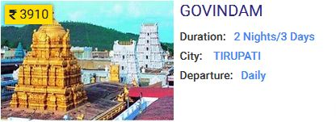

hpack1.jpg

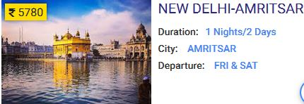

hpack2.jpg

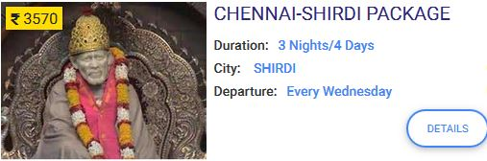

hpack3.jpg

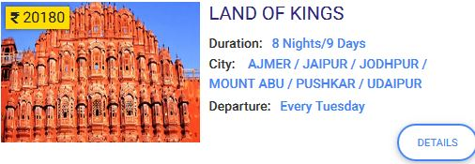

hpack4.jpg

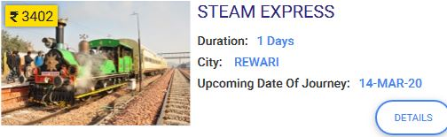

hpack5.jpg

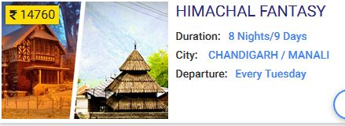

hpack6.jpg

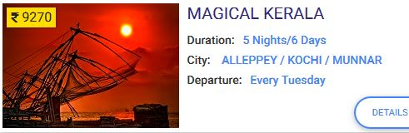

hpack7.jpg

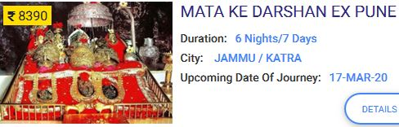

hpack8.jpg

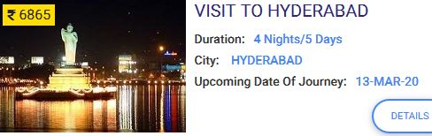

hpack9.jpg

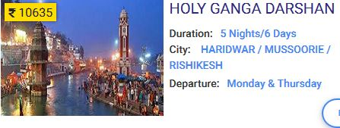

hpack10.jpg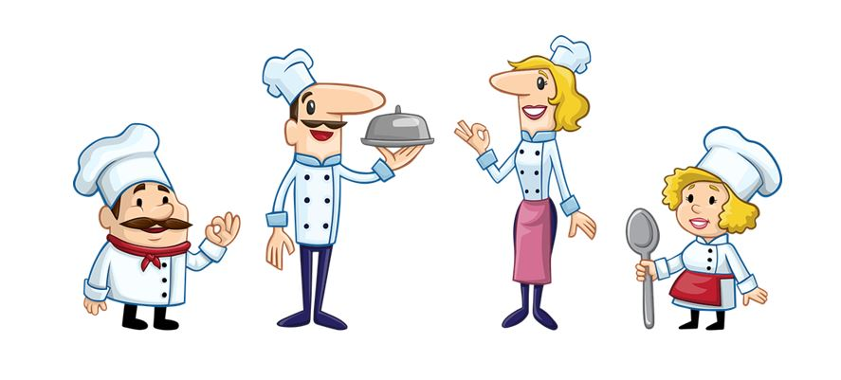

meal.jpg

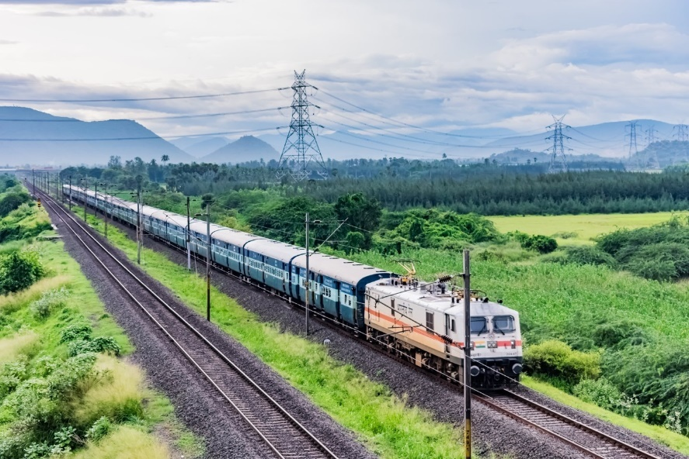

slide1.jpg

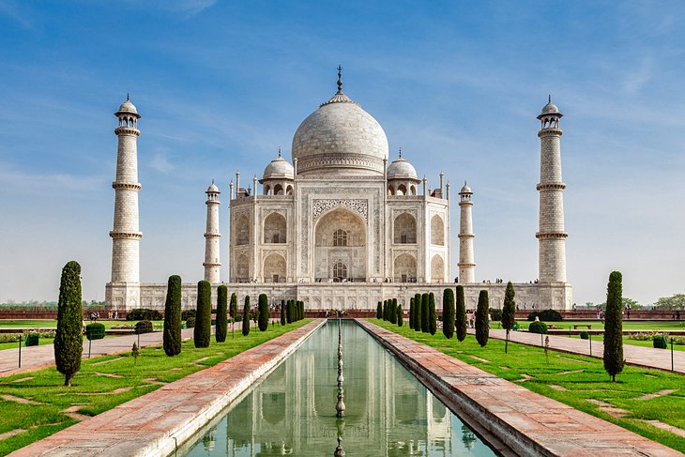

taj.jpg

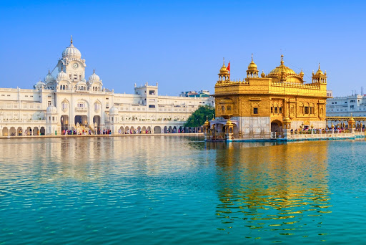

temple.jpg

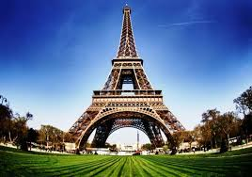

tower.jpg

**OUTPUT**

**Home page**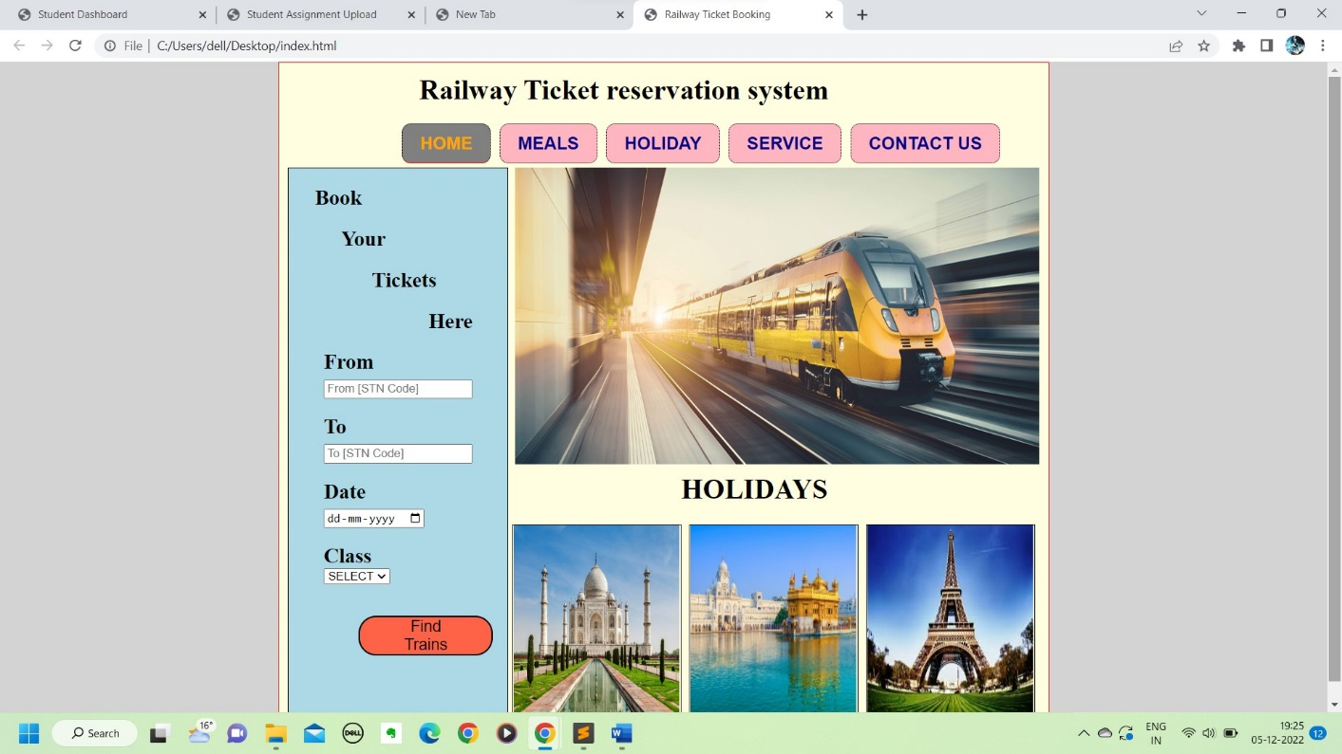

**TICKET BOOKING**

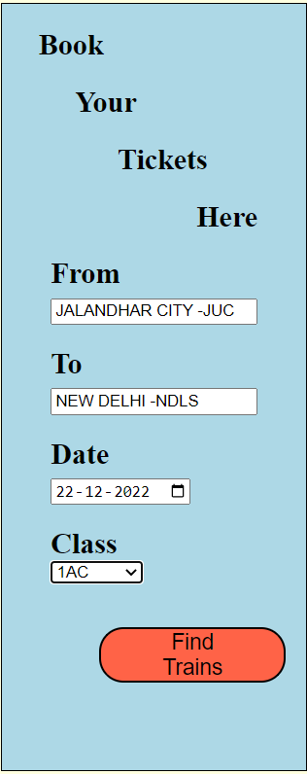

**Meals**

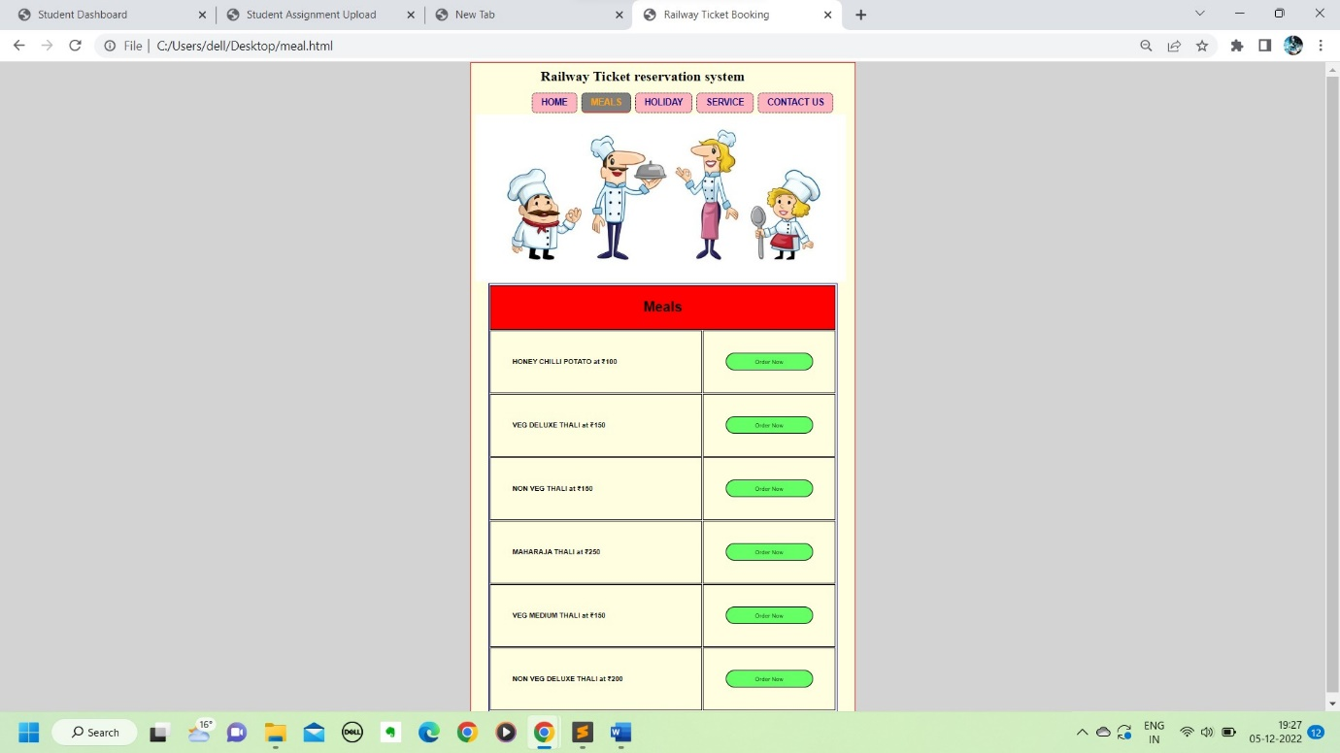

**Holiday**

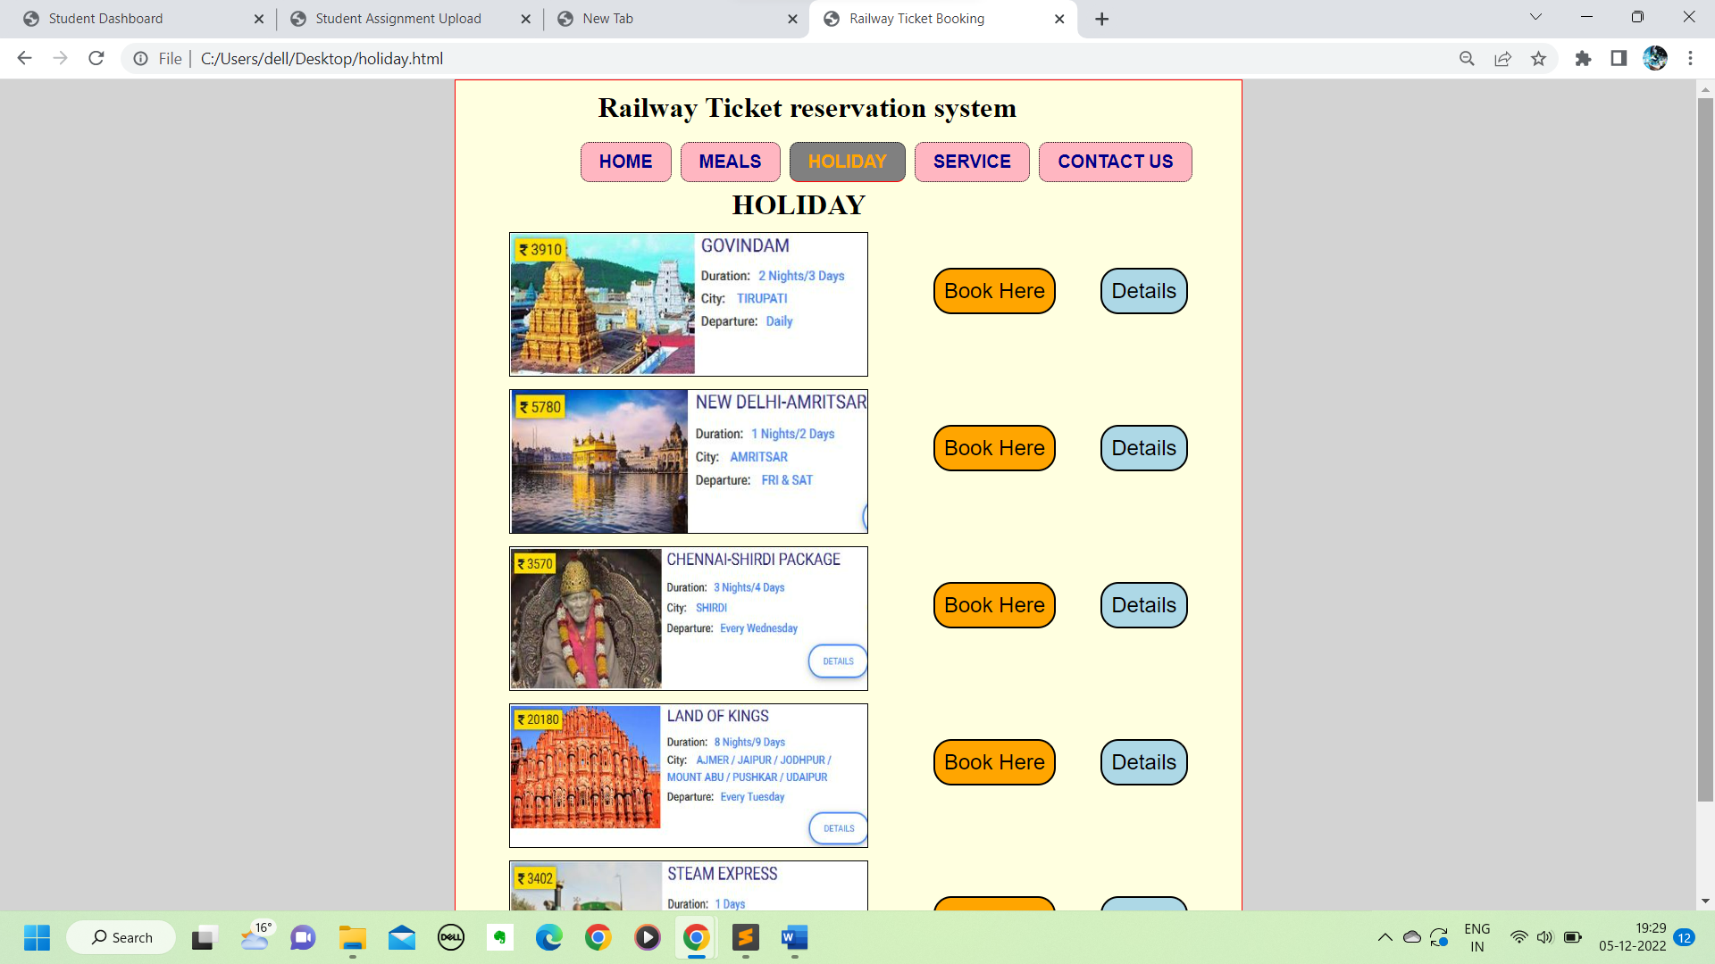

**Service**

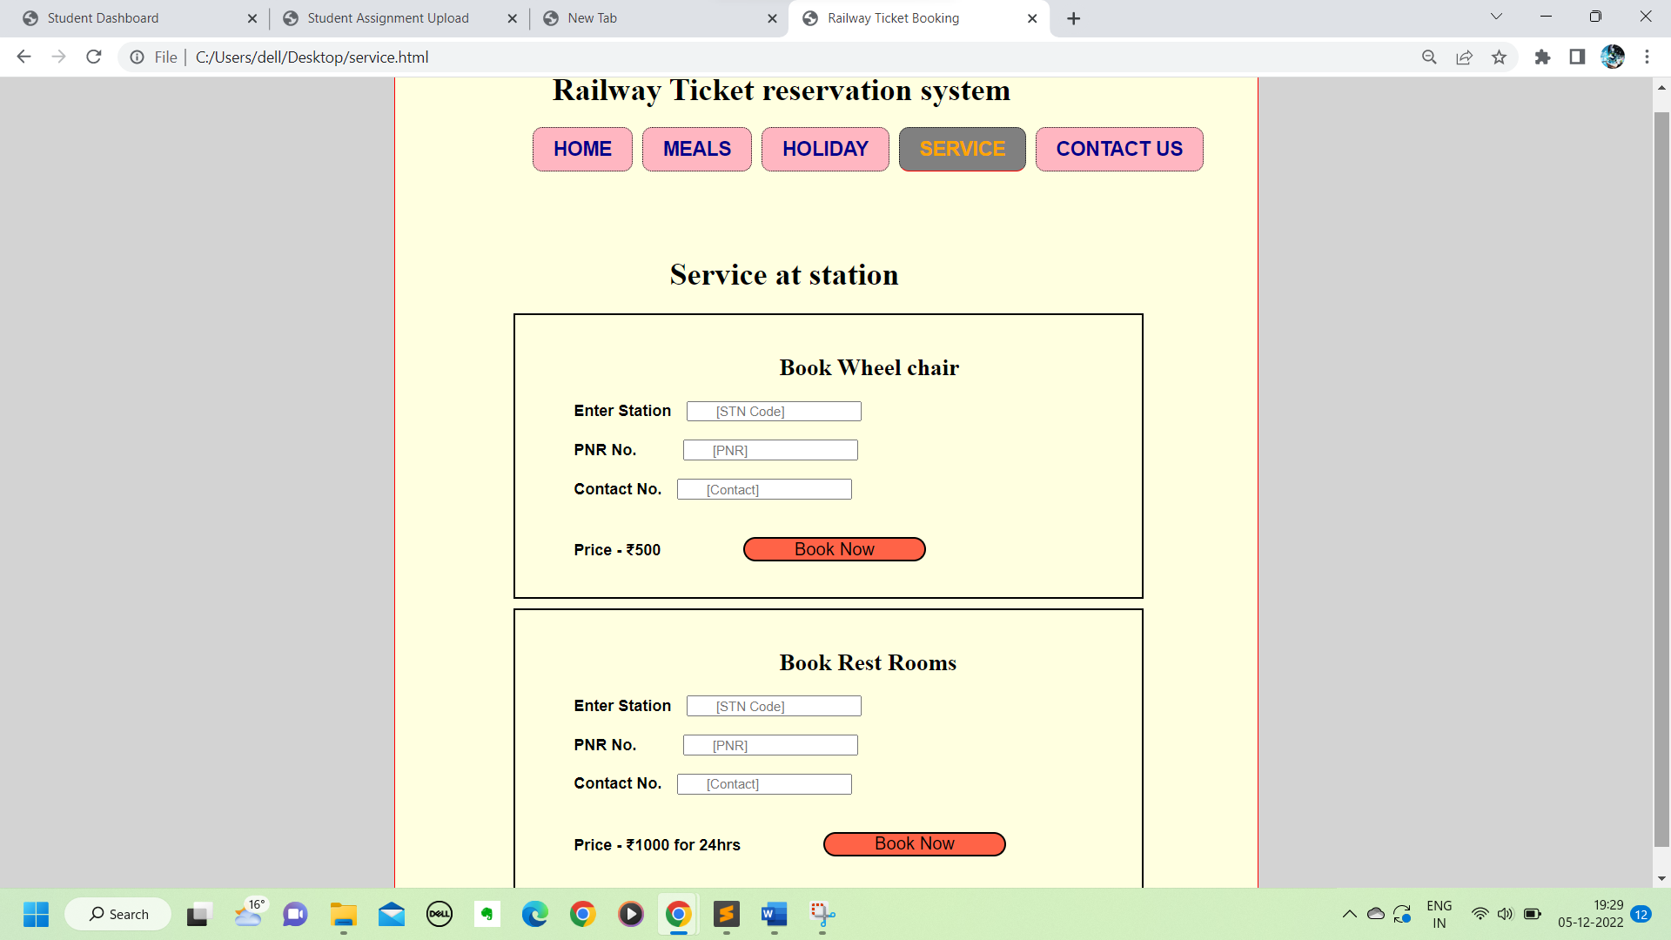

**Contact us**

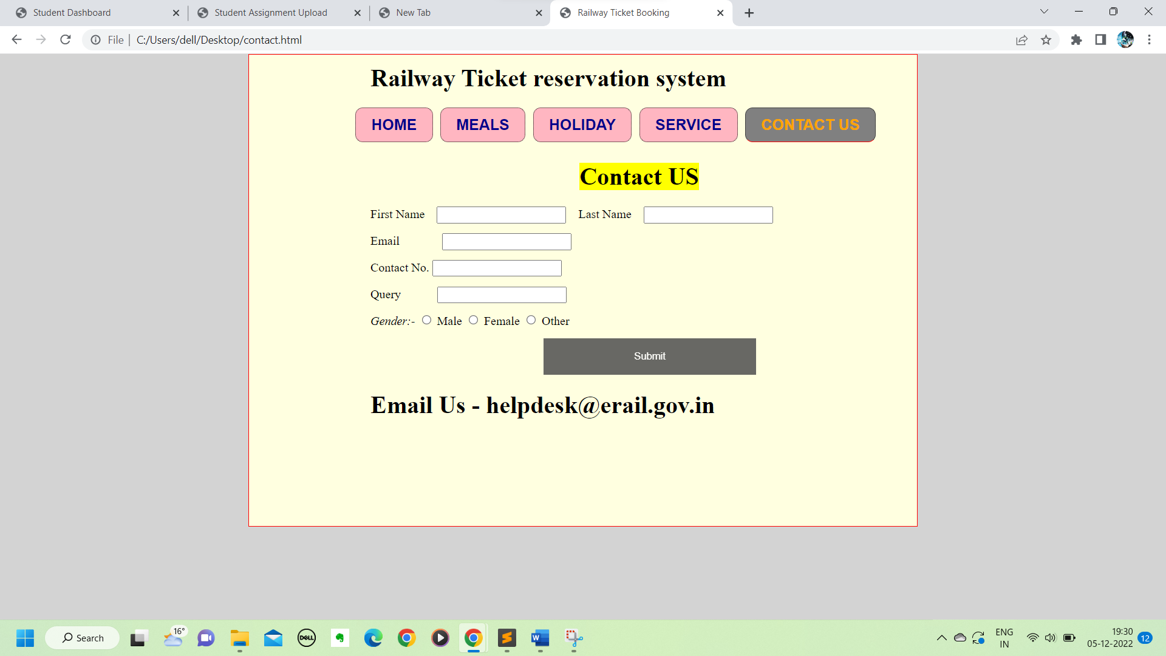

**Conclusion**

Practical Training is a very important part of the curriculum as it strengthens the concepts and enhances knowledge about the practical implementation of all the theory concepts, we have learnt so far in different subjects.

This summer training helped us learn a lot. In this training we did the project on railway reservation system. This project is used to keep a track on reserving the seat to the passenger. It helps managing the system very efficiently and conveniently.

Finally, this gives us a lot of mental satisfaction that the project we have worked upon is a real time project, which will be installed at the customer site after some more session of regress testing.

Although the project work has been done in a complete and detailed manner but due to the constraint of time, we could not include some more features we wanted to. We left these features as a part of the future development. As soon as we’ll get time we’ll try to add them to my project.

**REFERENCES:**

1. Faculty -Mr.Naresh

2. Website: https://www.google.com